**Python Lab Experiment – I**

**Name:** Rupam Ganguly **Class, Roll no.:** CB-40

OUTPUT👇

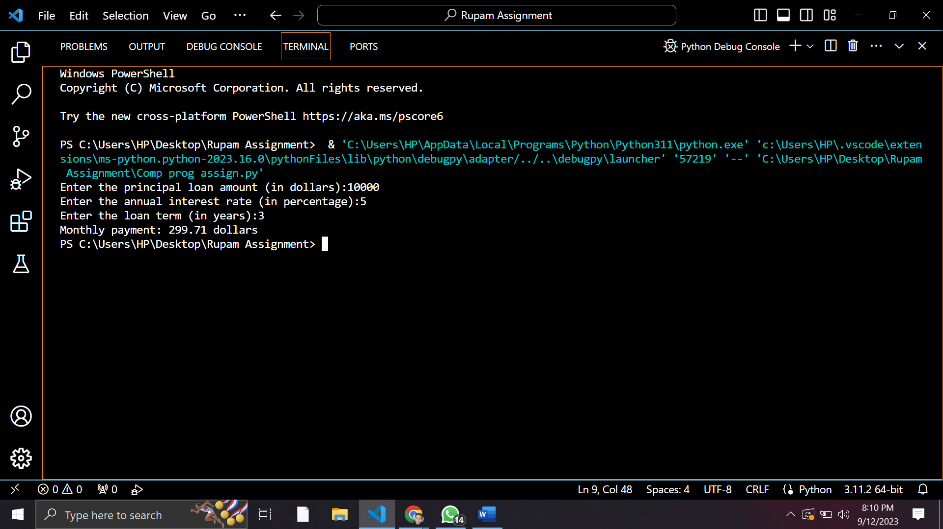

#CODING

P=eval(input("Enter the principal loan amount (in dollars):"))

r=eval(input("Enter the annual interest rate (in percentage):"))

n=eval(input("Enter the loan term (in years):"))

# Monthly interest rate

r=(r/12)/100

# Loan term (in months)

n=n*12

M=(P*r*(1+r)**n)/((1+r)**n-1)

print(f"Monthly payment: {round(M,2)} dollars")

**Assignment**

**Problem Statement:** Education Loan Calculator

**Description:**

You are tasked with creating a Python program that calculates the monthly payment for an education loan based on the principal amount, annual interest rate, and the loan term (in years) provided by the user.

The formula to calculate the monthly payment for a loan is given by:

where:

• M is the monthly payment

• P is the principal loan amount

• r is the monthly interest rate (annual interest rate divided by 12 and then

divided by 100)

• n is the total number of payments (loan term in years multiplied by 12)

**Input:**

• Principal loan amount (P) in dollars.

• Annual interest rate (r) in percentage.

• Loan term in years (n).

**Output:**

• Monthly payment (M) in dollars.

**Sample Input:**

Enter the principal loan amount (in dollars): 10000

Enter the annual interest rate (in percentage): 5

Enter the loan term (in years): 3

**Sample Output:**

Monthly payment: 299.71 dollars